

STINK3024 NEURAL NETWORK
Semester I Session 2025/2026 (A251)

ASSIGNMENT 1

Submitted to:
Associate Prof. Dr. Azizi Bin Ab Aziz

Submitted by:
301844 | MOHAMAD IMRAN BIN MOHAMAD MANSOR

School of Computing
UNIVERSITI UTARA MALAYSIA

PART A
Topic #1 : Introduction to Neural Networks
- Describe the actual process of our biological neuron and how it has inspired the development of artificial neural networks.
The biological neuron exist in our body are Dendrites that can receives activation from other neurons, Soma that can process the input from incoming activation and convert into output, Axons that can act as transmission line to connect to other neurons and Synapses that can strengthen the signal.
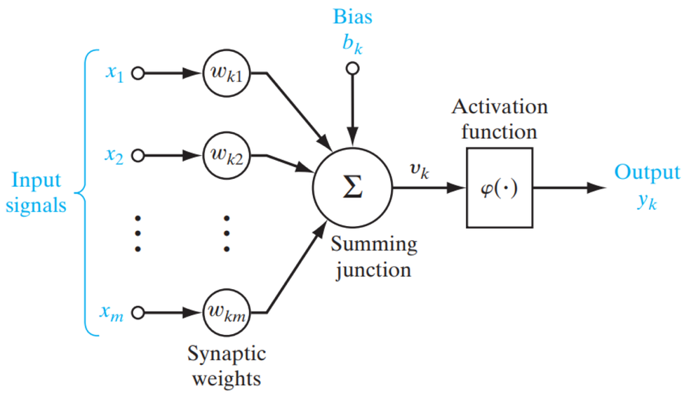
Artificial neural network uses the same biological neuron for example Input (x1,x2,xm) are like Dendrites to receives input, Weights (wk1,2k2,wm) are Synapses to control the signal strength, Summation Junction is Soma to process the signal and lastly Axon is the output.
- Read the following scenarios
“A neuroscientist argues that artificial neural networks should incorporate temporal spikes and neurotransmitter dynamics, while an AI engineer claims current mathematical models already capture sufficient functionality”

- Explain what each side (argument) means.
  - Neuroscientist : argues that Neural Network missing biological function such as spikes and neuro transmitter dynamics
  - AI Engineer : argues that current mathematical models in Neural Network can solves already problem without needing complex biological function
- Discuss which aspects of brain functioning might improve artificial neural networks if implemented and which are unnecessary for efficient computation
Temporal Spiking (Spiking Neural Networks - SNNs): This is arguably the most promising area.
- Efficiency: In an SNN, neurons only consume energy when they fire a spike. This is much more power-efficient than current ANNs, where all neurons in a layer perform a calculation in every pass. This could be revolutionary for running AI on low-power devices such as phones
- Temporal Data: Our world is based on time. SNNs are naturally built to process real-time, asynchronous streams of data (like video, audio, or sensory input), which can be awkward for traditional ANNs.

- Discuss why ANNs require large datasets and many computational loops (iterations/ epochs) whereas biological learning can happen with few examples.
  - To learn general pattern (Generalization): The goal of ANN is to find and learn the pattern that define a category
  - It require many computational loops or known as Epoch because learning rate requires small steps. If the learning step is to high, the actual will be over the target

- Discuss FIVE (5) main advantages and disadvantages of using neural network applications in a real-world context.
Advantages :
- Can handle complex data : Neural Network can process and analyse complex data to handle tasks like image recognition
- Non Linear modelling capabilities : Neural Network can model and learn non-linear relationships in data
- Robust to incomplete data : Neural Network can perform well even when the input data has missing values
- Adaptive learning : Neural Network can learn from experience over and over to improve their performance
- Feature extraction capabilities : Neural Network can automatically extract features from raw data
Disadvantages :
- Requires large amounts of labeled training data : Training effective neural networks typically requires large amount of labeled data that can be hard to obtain
- Computationally intensive and resource consuming : Neural Network requires high computational power and resources to train
- Complexity and difficulty in model tuning : Designing, tuning and optimizing Neural Network can be complex and requires expertise
- Lack of transparency in decision making : The Neural Network complexity is hard to provide clear explanations for their predictions
- Ethical considerations in sensitive decision making : The Neural Network can raise issue of bias and fairness in certain areas

Topic #2 : Linear Models and Perceptron
- Explain how Hebbian learning differs from Perceptron learning in
  - Use of target outputs
    - Hebbian learning : does not use target outputs because it is unsupervised learning
    - Perceptron learning : Use target output because it is supervised learning

  - Update Rule
    - Hebbian learning : ${{∆w}_{i}\left(t\right)= x}_{i}y$
    - Perceptron learning : $∆w_{i} =α\left(Y_{target}-Y_{output}\right)x_{i}$

  - Supervised vs unsupervised nature
    - Hebbian learning : learn strengthen the weight if the neighbouring neuron activates or deactivates at the same time making and finding the signal correlation making it a UNSUPERVISED nature
    - Perceptron learning : requires a target output that is the target value making it a SUPERVISED nature

  - Would the same dataset produce the same final weights under Perceptron learning?
No because in Perceptron Learning , the final weights will be updated based on propagated errors during learning process.
- This question requires the execution of a given Python code (related to our previous hands-one example)
(file: STINK3014_Assignment01_Driving_Satisfaction_Hebbian_Model.py).
Based on this file, you are required to answer the following questions with experimental results (by varying related parameters as needed for related questions) :
  - Without changing any parameters, discuss which features are more strongly correlated with driver satisfaction.

X3 (Quality of Journey) because in the dataset, within 4 input pattern , X3 scores 3 out of 4 patterns making it is the highest features that are correlated with driver satisfaction.

  - Discuss the role of the learning (η) in this code. Based on your experiments, what would happen if η were too small (e.g., 0.001) or too large (e.g., 0.99)?
If the n were to small : the final weights will be the same as initial weight because the model learn to small
If the n were to large : the final weights value will be too large because the model learn too fast making it exceed the target value
  - The initial weights are all set to 0.33. Discuss how different initial weights might affect the learning trajectory. Would the final weight pattern be the same? Why or why not?
The different initial weight might affect the learning trajectory because the initial weights directly determine the output $y$ of the very first training pattern.

  - Explain the real-world application of these weights (related to the driving satisfaction scenario).
The weight represents the represent the quality that determine the driver satisfactions score. In the end the Hebbian Learning, the largest updated weight influences the driver satisfaction. In the provided coding, Weight 3 has the largest updated weight that is Quality of Journey.

- What is meant by an activation function in artificial neurons?
A function of a node that defines the output of that node given an set of inputs

- You are given the following binary classification dataset representing the logical AND function:
with four input-output pairs (x1,x2, a) as [ #1(0,0,0), #2(0,1,0), #3(1,0,0), #3(1,1,1)]. The
perceptron model computes the outputs as:

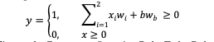
And updates its weights according to the Perceptron Learning Rule (Delta Rules)
𝑤(𝑖,𝑡+1) = 𝑤(𝑖,𝑡) + 𝜂. (𝑎𝑖− 𝑦𝑖). 𝑥𝑖
𝑤(𝑏,𝑡+1) = 𝑤(𝑏,𝑡) + 𝜂. (𝑎𝑖− 𝑦𝑖)

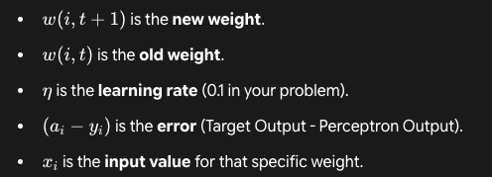

Where w1=0.2, w2 = 0.2, b = 1, wb = -0.1 and learning rate η = 0.1. Using this information, show computational /calculation steps when you are training the perceptron for two epochs using the logical AND function dataset for THREE (3) epochs.
w1,w2 = 0.2
b = 1
wb = =0.1
n = 0.1

record | X1 | X2 | Target (a)
1 | 0 | 0 | 0
2 | 0 | 1 | 0
3 | 1 | 0 | 0
4 | 1 | 1 | 1

Epoch 1 :  1st step : input-output pair [(0,0)(0)]  Youtput = (0)(0.2) + (0)(0.2) + (1)(-0.1) = -0.1  -0.1 is less than 0 = output : 0  therefore e = (Ytarget – Youtput) = (0-0) = 0  2st step : input-output pair [(0,1)(0)]  Youtput = (0)(0.2) + (1)(0.2) +(1)(-0.1) = 0.1  0.1 is more than 0 = output :1  therefore e = (Ytarget – Youtput) = (0-1) = -1  w1(new) = (0.2) + (0.1)(-1)(0) = 0.2  w2(new) = (0.2) + (0.1)(-1)(1) = 0.1  wb(new) = (-0.1) + (0.1)(-1) = -0.2  3rd step : input-output pair [(1,0)(0)]  Youtput = (1)(0.2) + (0)(0.1) +(1)(-0.2) = 0  0 is equal to 0 = output :1  therefore e = (Ytarget – Youtput) = (0-1) = -1  w1(new) = (0.2) + (0.1)(-1)(1) = 0.1  w2(new) = (0.1) + (0.1)(-1)(0) = 0.1  wb(new) = (-0.2) + (0.1)(-1) = -0.3  4th step : input-output pair [(1,1)(1)]  Youtput = (1)(0.1) + (1)(0.1) +(1)(-0.3) = -0.1  -0.1 is less than 0 = output :0  therefore e = (Ytarget – Youtput) = (1-0) = 1  w1(new) = (0.1) + (0.1)(1)(1) = 0.2  w2(new) = (0.1) + (0.1)(1)(1) = 0.2  wb(new) = (-0.3) + (0.1)(1) = -0.2  Updated weight after EPOCH 1 :  W1 = 0.2  W2 = 0.2  WB = -0.2  Input Weight Target Output Update New Weight  (0, 0) (0.2, 0.2) 0 0 NO (0.2, 0.2)  (0, 1) (0.2, 0.2) 0 -1 YES (0.2, 0.1)  (1, 0) (0.2, 0.1) 0 1 YES (0.1, 0.1)  (1,1) (0.1, 0.1) 1 0 YES (0.2, 0.2) | Epoch 2 :  1st step : input-output pair [(0,0)(0)]  Youtput = (0)(0.2) + (0)(0.2) + (1)(-0.2) = -0.2  - 0.2 is less than 0 = output : 0  therefore e = (Ytarget – Youtput) = (0-0) = 0  2st step : input-output pair [(0,1)(0)]  Youtput = (0)(0.2) + (1)(0.2) +(1)(-0.2) = 0  0 is equal to 0 = output :1  therefore e = (Ytarget – Youtput) = (0-1) = -1  w1(new) = (0.2) + (0.1)(-1)(0) = 0.2  w2(new) = (0.2) + (0.1)(-1)(1) = 0.1  wb(new) = (-0.2) + (0.1)(-1) = -0.3  3rd step : input-output pair [(1,0)(0)]  Youtput = (1)(0.2) + (0)(0.1) +(1)(-0.3) = -0.1  -0.1 is less than 0 = output : 0  therefore e = (Ytarget – Youtput) = (0-0) = 0  No need to calculate the weight because error  is 0  4th step : input-output pair [(1,1)(1)]  Youtput = (1)(0.2) + (1)(0.1) +(1)(-0.3) = 0  0 is equal to 0 = output :1  therefore e = (Ytarget – Youtput) = (1-1) = 0  No need to calculate the weight because the error is 0  Updated weight after EPOCH 2 :  W1 = 0.2  W2 = 0.1  WB = -0.3  Input Weight Target Output Update New Weight  (0, 0) (0.2, 0.2) 0 0 NO (0.2, 0.2)  (0, 1) (0.2, 0.2) 0 1 YES (0.2, 0.1)  (1, 0) (0.2, 0.1) 0 0 NO (0.2, 0.1)  (1,1) (0.2, 0.1) 1 1 NO (0.2, 0.2)
Epoch 3 :
1st step : input-output pair [(0,0)(0)]
Youtput = (0)(0.2) + (0)(0.1) + (1)(-0.3) = -0.3, -0.3 is less than 0 = output : 0
therefore e = (Ytarget – Youtput) = (0-0) = 0

2st step : input-output pair [(0,1)(0)]
Youtput = (0)(0.2) + (1)(0.1) +(1)(-0.3) =- 0.3, -0.3 is less than 0 = output :0
therefore e = (Ytarget – Youtput) = (0-0) = 0
No need to calculate the weight because error is 0

3rd step : input-output pair [(1,0)(0)]
Youtput = (1)(0.2) + (0)(0.1) +(1)(-0.3) = -0.1, -0.1 is less than 0 = output :0
therefore e = (Ytarget – Youtput) = (0-0) = 0
No need to calculate the weight because error is 0

4th step : input-output pair [(1,1)(1)]
Youtput = (1)(0.2) + (1)(0.1) +(1)(-0.3) = 0, 0 is equal to 0 = output :1
therefore e = (Ytarget – Youtput) = (1-1) = 0
No need to calculate the weight because the error is 0

Updated weight after EPOCH 3 :
W1 = 0.2
W2 = 0.1
WB = -0.3

Input | Weight | Target | Output | Update | New Weight
(0, 0) | (0.2, 0.1) | 0 | 0 | NO | (0.2, 0.1)
(0, 1) | (0.2, 0.1) | 0 | 0 | NO | (0.2, 0.1)
(1, 0) | (0.2, 0.1) | 0 | 0 | NO | (0.2, 0.1)
(1,1) | (0.2, 0.1) | 1 | 1 | NO | (0.2, 0.1)

  - Does the perceptron correctly classify all input patterns?
    - For the 1st Epoch , the perceptron misclassified pattern input 2 until 4
    - For the 2nd Epoch, the perceptron misclassified only 1 pattern that is input 2
    - After the 3rd Epoch , the perceptron correctly classifies all input patterns because there is no error

  - How does the bias term affect the decision boundary?
    - The bias term can affect decision boundary by making it flexible, for example without bias the equation only y=mx, but with bias the equation will be y=mx+c making the line of decision boundary.
      - For Example , without bias the decision boundary must follow through the (0,0) making it as restriction
      - If there are bias, the decision boundary can be flexible and remove the restriction

- Why is zero initialization of weight not a good practice?
  - Initializing all weights to zero Is a bad practice because it causes symmetry in the network.
    - If all weight starts as zero , the output of every neuron in a layer will be identical during first pass.
    - Then the weights will be updated by the exact amount, making it identical to each other in every epoch and cannot learn to do different things.

- Explain why linear separability a necessary condition for the single-layer perceptron is to converge.
  - A single layer perceptron is a linear classifier. Its only tool is for classifying data in a straight single line.
  - Converge means the algorithm finds a final set of weight that produces zero error for all training. If a dataset is linearly separable, it means such a line exists. The algorithm is guaranteed to eventually find it and converge.
Topic #3 : Multilayer Perceptron
- Explain the main goal of the backpropagation algorithm in training a multilayer perceptron.
To minimize error between predicted and target output

- Why is the differentiability of the activation function crucial in MLPs?
Differentiability is crucial because MLPs are trained using the backpropagation algorithm, which relies on gradient descent to update weights

- Define hidden layers, optimisers, epoch, batch size, and learning rate in the context of MLP training. Explain how varying each parameter affects:

Hidden Layers | Layers between the input and output layers where features are transformed and learned representations are formed.
Optimisers | Number of passes over full dataset; affects learning duration and convergence
Epoch | Number of passes over full dataset; affects learning duration and convergence
Batch Size | The number of samples processed before the model updates its weights.
Learning Rate (η) | A hyperparameter that controls the size of weight updates during training.

 | Convergence Speed | Stability of Learning | Model Generalization
Hidden Layers | Slower. More layers and neurons require significantly more computations per epoch. | Less Stable. Can lead to vanishing or exploding gradients in very deep networks, making training difficult. | Better (to a point): Can model more complex, non-linear patterns. Worse (if too many): High risk of overfitting (memorizing the data).
Optimisers | Faster. Advanced optimizers (like Adam) adapt the learning rate and often converge much faster than basic Stochastic Gradient Descent (SGD). | More Stable. Adaptive optimizers can handle "bumpy" loss landscapes more effectively and are less prone to getting stuck or diverging. | Often Better. By adapting, they can often find a better (flatter) minimum in the loss landscape, which tends to generalize well.
Epoch | - | Less Stable (if too many). Can lead to overfitting, where the model's weights become too specialized and unstable. | Better (to a point): The model needs enough epochs to learn the patterns. Worse (if too many): This is the classic definition of overfitting. The model memorizes the training data and fails to generalize to new, unseen data.
Batch Size | Faster (Large Batch): Fewer weight updates per epoch. GPUs are also highly optimized for processing large batches in parallel. | More Stable (Large Batch): Averages the gradients over more samples, leading to a "smoother" and more stable descent. | Worse (Large Batch): Tends to find "sharp" minima, which often generalize poorly.  Better (Small Batch): The noise from smaller batches acts as a regularizer, helping the model find generalize better
Learning Rate (η) | Faster (High LR): Takes large steps.  Slower (Low LR): Takes tiny, cautious steps. | Less Stable (High LR): Can "overshoot" the optimal solution, causing the loss to bounce around or even explode (diverge).  More Stable (Low LR):Takes small, safe steps. | Poor (High LR): The model will likely miss the optimal solution entirely.  Poor (Low LR): May get "stuck" in a poor local minimum and never find a good solution.

- Explain the purpose of a loss function in backpropagation with respect to weight functions.

The loss/error function provides the primary signal for learning by quantifying how wrong the model's prediction (y) is compared to the correct target (t).The entire goal of training is to find the weights that minimize the error.

- Compare Mean Squared Error (MSE) and Cross-Entropy Loss in the context of MLPs. Which loss function is more suitable for regression problems/classification problems

The most suitable function for regression problems is MSE because the main goal are to minimize squared differences between the actual target values and predicted values. Meanwhile for Cross-Entropy Loss, are much more suitable for classification problems because the main goal are to minimize the differences between the actual class label and predicted class label.

OUTPUT GRAPH
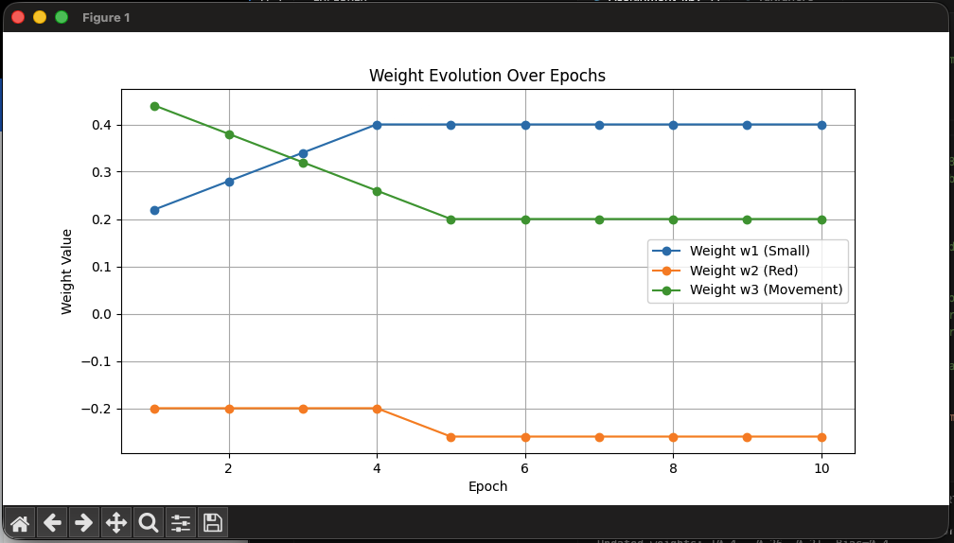
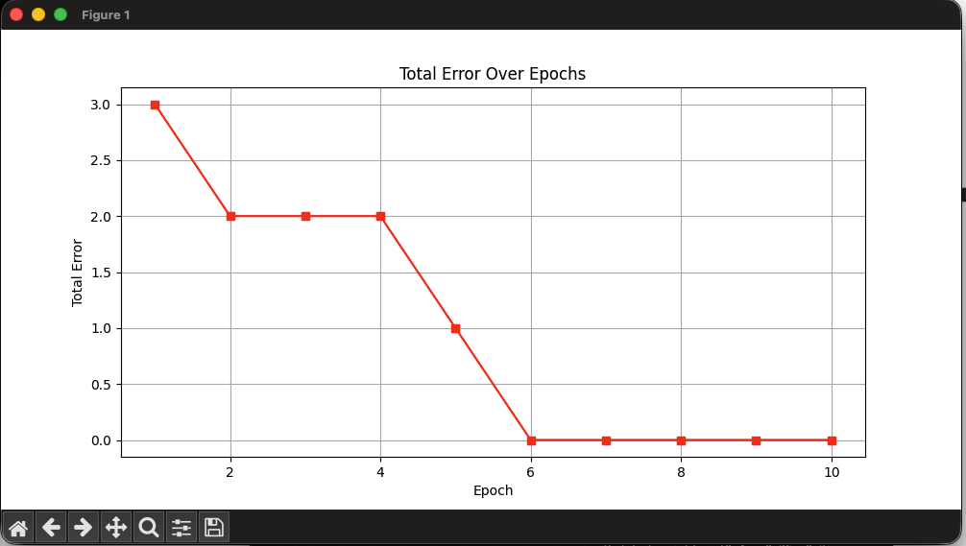

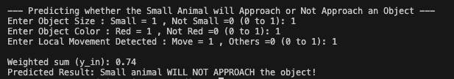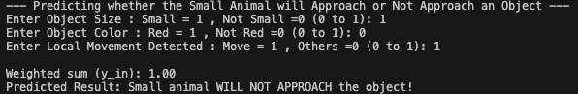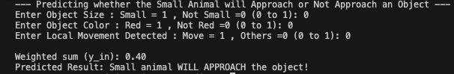

OUTPUT PREDICTION
SMALL | RED | MOVEMENT | APPROACH
1 | 1 | 1 | 0 | NOT APPROACH
1 | 0 | 1 | 0 | NOT APPROACH
0 | 0 | 0 | 1 | APPROACH

APPENDIX
# Imran Mansor 301844
# Assignment 1 :Perceptron Model to Predict Small Animal Will Approach an Object
# STINK 3014 - Neural Networks

import matplotlib.pyplot as plt

# Learning rate
# I tried using higher learning rates like 0.8, but they caused the weights to not converge properly and making the wrong predictions
# I tried lower learning rates like 0.00001, but they made the training process very slow and still has errors after 10 epochs. If i need to use this i need to increase the epochs to more than 50 to make sure the model converges
# Finally,I choose 0.06 because after several trials, I found that this learning rate gives a good balance between convergence speed and stability
eta = 0.06

# I choose to fix it to 10 for because the model stop coverging around epoch 4, so 10 is sufficient to make sure the model converges.
epochs = 10
# Initial weights (importance of each factor)
# x1 = Small is 0.1 because size is quite important for small animals to decide to approach an object if the object is small, then small animal will approach it
# x2 = Red is -0.2 because color is less important for small animals to decide to approach an object if the object is red, it could be a sign of danger (like a predator)
# x3 = Movement is 0.5 because movement is very important for small animals to decide to approach an object because if the movement is detected, it could be a predator
w = [0.1, -0.2, 0.5]
bias = 0.4 #Bias weight is total of the initial weights

# Display original weights
print("Original weights (initial guesses of importance):", [round(weight, 2) for weight in w])
print("Bias:", bias, "\n")

# Example dataset: [x1, x2, x3, y]
# x1 = Small
# x2 = Red
# x3 = Movement
# y: 1 = Approach, 0 = Not Approach
data = [
[0, 1, 1, 0], # Red & Movement = Not Approach
[0, 1, 0, 0], # Red only = Not Approach
[1, 0, 0, 1], # Small only = Approach
[1, 1, 0, 1] # Small & Red = Approach
]

# Activation function (step)
def activation(y):
return 1 if y >= 0.5 else 0 #threshold at 0.5

# To record weights and errors
weight_history = []
error_history = []

# Training loop
for epoch in range(epochs):
total_error = 0
print(f"\n=== Epoch {epoch+1} ===")

for idx, sample in enumerate(data):
x1, x2, x3, actual = sample
inputs = [x1, x2, x3]

# Compute weighted sum
y_in = sum(inputs[i] * w[i] for i in range(3)) + bias
predicted = activation(y_in)

# Compute error
error = actual - predicted
total_error += abs(error)
print(f"Trip {idx+1}: Inputs={inputs}, Actual={actual}, Predicted={predicted}, Error={error}")

# Update rule
for i in range(3):
w[i] += eta * error * inputs[i]
bias += eta * error
print(f"Updated weights: {[round(weight, 2) for weight in w]}, Bias={round(bias, 2)}")

# Record after each epoch
weight_history.append(w.copy())
error_history.append(total_error)

# --- Final results ---
print("\nFinal learned weights:", [round(weight, 2) for weight in w])
print("Final bias:", round(bias, 2))

# --- Visualization Section ---
# Convert weight history for plotting
w1_vals = [weights[0] for weights in weight_history]
w2_vals = [weights[1] for weights in weight_history]
w3_vals = [weights[2] for weights in weight_history]
epochs_range = range(1, epochs + 1)

# --- Plot weight changes ---
plt.figure(figsize=(10, 5))
plt.plot(epochs_range, w1_vals, marker='o', label='Weight w1 (Small)')
plt.plot(epochs_range, w2_vals, marker='o', label='Weight w2 (Red)')
plt.plot(epochs_range, w3_vals, marker='o', label='Weight w3 (Movement)')
plt.title('Weight Evolution Over Epochs')
plt.xlabel('Epoch')
plt.ylabel('Weight Value')
plt.legend()
plt.grid(True)
plt.show()

# --- Plot error trend ---
plt.figure(figsize=(10, 5))
plt.plot(epochs_range, error_history, marker='s', color='red')
plt.title('Total Error Over Epochs')
plt.xlabel('Epoch')
plt.ylabel('Total Error')
plt.grid(True)
plt.show()

# --- Prediction using trained model ---
print("\n--- Predicting whether the Small Animal will Approach or Not Approach an Object ---")
x1 = float(input("Enter Object Size : Small = 1 , Not Small =0 (0 to 1): "))
x2 = float(input("Enter Object Color : Red = 1 , Not Red =0 (0 to 1): "))
x3 = float(input("Enter Local Movement Detected : Move = 1 , Others =0 (0 to 1): "))

inputs = [x1, x2, x3]
y_in = sum(inputs[i] * w[i] for i in range(3)) + bias
predicted = activation(y_in)

print(f"\nWeighted sum (y_in): {y_in:.2f}")
if predicted == 1:
print("Predicted Result: Small animal WILL NOT APPROACH the object!")
else:
print("Predicted Result: Small animal WILL APPROACH the object!")

